# PDS

Livrable De R3

BOUNEKTA Youcef

Manuel utilisateur :

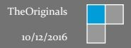



# Contenu

# User

# Manual

This module of the application will allow the user to realize a repair operation.

When the application is launched, the repairman should firstly sign-in with his own login and password before getting in the application, after a verification of the system, if everything goes well and the data of the user are correct, the user can do a whole of tasks with all simplicity, here as you can see on the preview below, a first view appears to the repairman immediately after a right and full sign-in to the application:

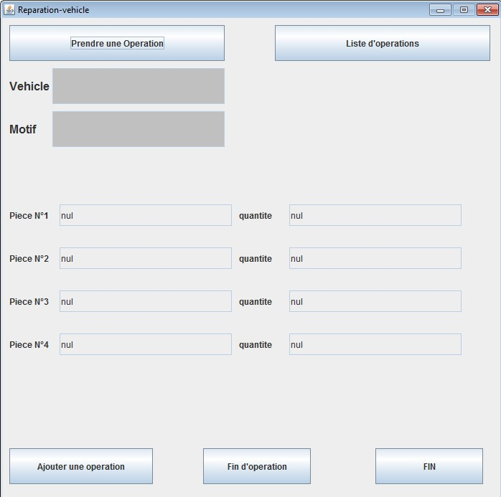

This view as you can clearly see it, contains 5 buttons .

First of all, the user have the possibility to choose from a large list of the main operations that exist about any vehicle which resides in the deposit

Here is a preview of showing how the button « Liste d’operations » works,

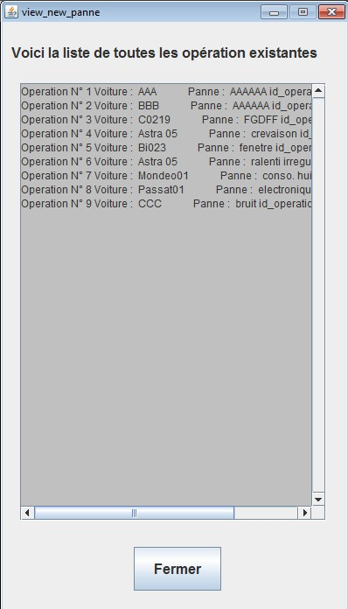

On the other hand, he will be obliged to deal with most urgent reparation, To take action, the repairer have to select this urgent case, only by clicking on the button « prendre une operation », automaticity, the name of the breakdown and the vehicle will appears in the The two text areas (car, pattern).

Here is a preview of showing how the button « prendre une operation » works,

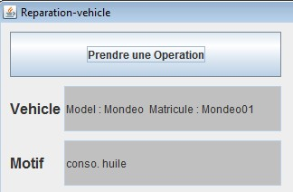

It means two new buttons :

1. Vehicle information
2. Add piece

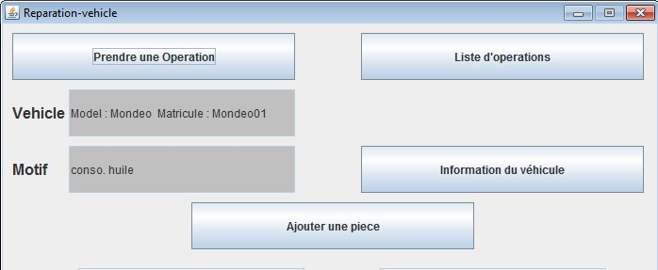

The repairer can consult the list of information concerning the vehicle in breakdown, in order to have a first idea on it.

By clicking on the vehicle info button, the information (model, Brand, estimated time, number of the vehicle position in the depot, etc.) will be displayed in this way.

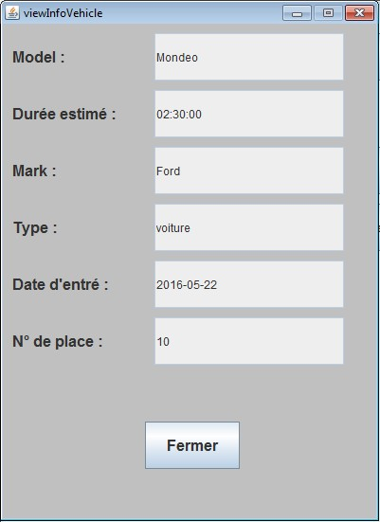

The repairer must select the parts he needs to carry out this operation and for this purpose, it is necessary to click on the button << add piece >>, after that, a view will

be displayed, and the repairer must enter the name of the Piece concerned, And the quantity of it.

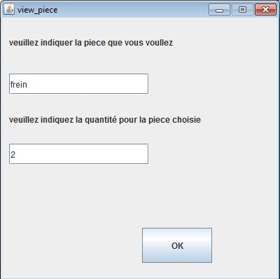

By clicking on the <ok> button, the system will reserve the validated piece and it will be displayed in the main view (name piece, quantity)



During the operation if the repairer discovers a problem that will require another repair (new breakdown), then the repairer must indicate the problem by clicking on the <add breakdown> button, a view will be displayed, the repairer must indicate the name of the breakdown and click on the <OK> button to save this one.

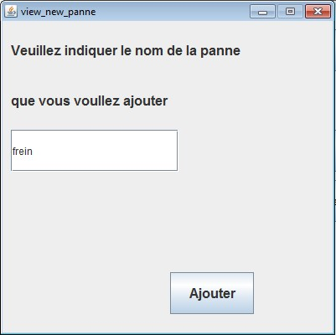

When the repairer finishes a task, he must click on the <find operation> button, another button will be displayed, by clicking on this new button the repairman will save the information concerning this reparation. The system will display a success oparation message and also the number of breakdown remaining to be repaired, in order to make the vehicle operational again.

